What is Service Management System?

Service Management



**Information Technology Service Management** (**ITSM**) is the activities that are performed by an organization to design, plan, deliver, operate and control information technology (IT) services offered to customers.

Differing from more technology-oriented IT management approaches like network management and IT systems management, IT service management is characterized by adopting a process approach towards management, focusing on customer needs and IT services for customers rather than IT systems, and stressing continual improvement.

ISO/IEC 20000 is the international ITSM (IT service management) standard. It enables IT departments to ensure that their ITSM processes are aligned with both the needs of the business and international best practice.

The adoption of an SMS is a strategic decision for an organization and is influenced by the organization’s objectives, the governing body, other parties involved in the service lifecycle and the need for effective and resilient services.

Implementation and operation of an SMS provides ongoing visibility, control of services and continual improvement, leading to greater ef Where & how can Service Management System be applied?

A **Service Management System** (**SMS**) can be applied to any organization, irrespective of size or industry sector. QMS principle approach has following basic principles & strategies in place:

|  |  |
| --- | --- |
| Principles | Strategies |
| * CUSTOMER FOCUS * LEADERSHIP * ENGAGEMENT OF PEOPLE * PROCESS APPROACH * IMPROVEMENT * EVIDENCED BASED APPROACH * RELATIONSHIP MANAGEMENT | * Focus on Customer Obligations * Process Approach – Design Fails Service fails * Risks for all IT domains before Design * PDCA > Plan Do Check Act * Annex SL Model > Frame Work for System Design * The only standard in ISO having Service Design & Development life cycle |

What can make Service Management System journey successful?

To implement & get maximum benefited from SMS, there has to be ***baseline mindset principles***, in which every member of the organization (including Top Management) should believe in:

|  |  |
| --- | --- |
| Mind Set for SMS | Benefits of SMS |
| * The internal System implemented is to use the QMS Principles in the right spirit; * Open mind to adopt culture for new understanding & learning concepts, technology, processes, etc.; * **Always believe that, what we know today is not enough and not the end**; * Always believe in and practice team work, commitment to improve and believe in that: * **Any System to be in such a manner that people depend on System, & not the other way round**”; * Ask self-question all the time - “Am I interpreting the requirements of SMS Standard in current manner?; * Importance has to be given to documentation with Criteria inbuilt into it for internal transparency; * Believe in building up Process **KEDB** (Known Error Data Base) – and update in disciplined manner and ensure that this is accessible to every one | * Offers competitive differentiation by demonstrating reliability and high Service of service. * Gives access to key markets, as many organizations in the public sector mandate that their IT service providers demonstrate compliance with ISO 20000. * Assures clients that their service requirements will be fulfilled. * Enforces a measurable level of effectiveness and a culture of continual improvement by enabling service providers to monitor, measure and review their service management processes and services. * Drives down the costs of conformance to a multitude of laws and standards. * Helps leverage ITIL practices to optimize resources and processes. |



**Service Design helps to innovate (Create new) or improve (existing) services to make them more productive, usable, desirable for clients and efficient as well as effective for organizations. It is a new holistic , multi-disciplinary, interactive fields.**

**Service Design Build & Transition**

The Service sector contributes, on an average of 70% towards GDP of any country. However service are not as productive to organizations and much of satisfaction to customers, as expected as services have service design problems. Service Design unlike Product Design is not much known to Industry except to Information Security based industries. In this current world, all 100% of the services are now IT driven – Hospitals, Airlines, Communications, Courier, Railways, etc. - you think of. All these services are called business for society.

**Some are Critical like Hospitals, Airlines etc. When it comes to customer expectations, every one says “NOW, ERROR FREE & SECURE”. To achieve this, one has to align all required resources which are capable and have enough capacity to deliver as desired, including Information Technology. This alignment of these resources in systematic manner to achieve designed objective is what is called as Service Design**.

**ISO 20000-1:2018 is the only standard in ISO family, which is exclusively for Service Design.**

What is Annexure L?

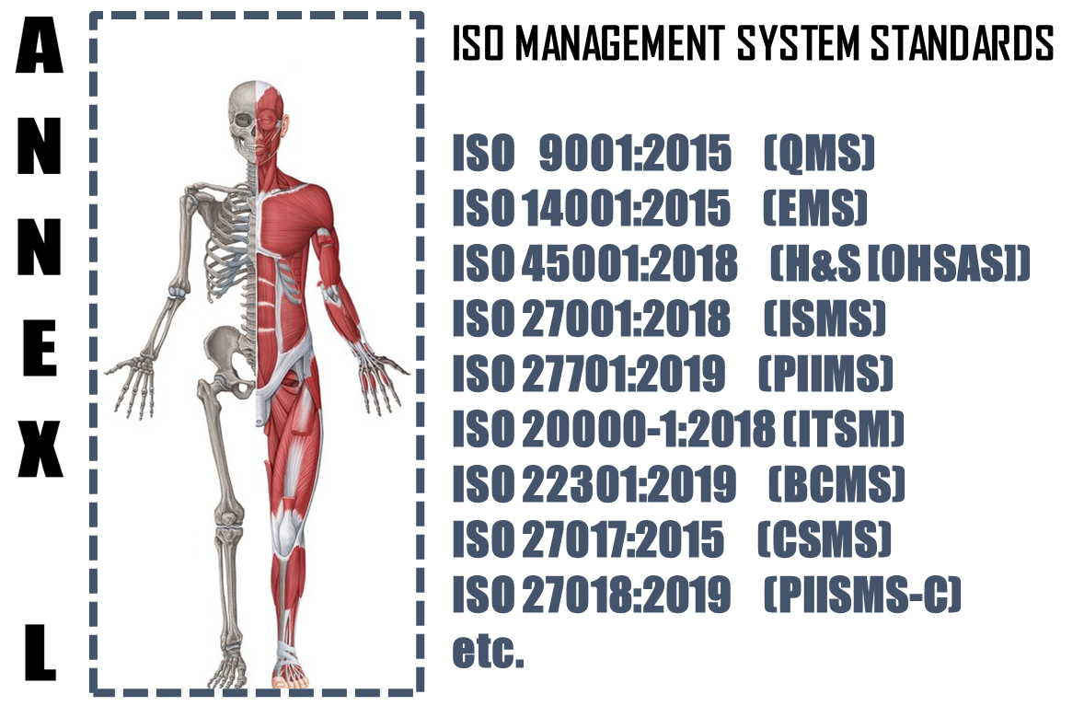

The **Annex L** (now renamed as Annex L in the 2019th edition from Annex SL) is a section of the ISO/IEC Directives part 1 that prescribes how ISO Management System Standard (MSS) standards should be written. The aim of Annex L is to enhance the consistency and alignment of MSS by providing a unifying and agreed-upon high level structure, identical core text and common terms and core definitions. The aim being that all ISO Type A MSS (and B where appropriate) are aligned and the compatibility of these standards is enhanced.

So in short we can say that Annex L is the Skeleton of ISO Management Systems and all standards are now aligned as per Annex L and all the common elements terms and definitions have also been standardized. This has been done to bring in Standard in the Structure, which was not the case in the past, though the intention was the same. So we can say, out of Intent and Content of SMS, Content has undergone a change, in the form of Anne L.

What To Do in Implementing Service Management System?

Based on the Scope and Context, following activities have to be performed in logical sequence. These guidelines given below are only basic milestones and a lot of activities may have to be streamlined as per the standard, based on Scope & Context.

|  |  |  |  |  |
| --- | --- | --- | --- | --- |
| **Step #** | **Requirement of SMS** | **What needs to be done** | **In what way IRCBO can contribute** | **Tools Recommended** |
| 1 | Documentation | * Define Scope (Technical [Product/Services] and Territorial Scope (# Locations) where the MS is needed. The Org. Management decides the specific scope; * Defining the External & Interested Parties, their business relationship with Org. (in relevance to scope), Identification of critical processes, Information & Information classification); | IRCBO’s Qualified & Experienced consultants can help you in designing, defining, Implementing, monitoring and Improving the MS.  Note: Our contracts can also be associated after Certification for Maintenance of Management System through our digitized tool contributions – aim is to make any MS a plug and play for most effective Controls & Complying | IRCBO Tool Kit which includes all solutions for Implementation and backed up by IRCBO Designed Software in cloud for :   * Online training   (including  Induction for new employees, awareness & unlimited Internal Auditor Training & Qualification   * Online Internal Auditing Software |
| 2 | Implementation | * Defining, approving, sharing QMS Policy; * Assigning Responsibilities and Authorities in more transparent manner; * Participating in Risk Mechanism and approving Residual Risk and Incident investigations; * Focusing on Increasing Competency, Considering Internal Audit Findings seriously for Timely Corrective Actions in effective manner; * Maintaining good discipline in demonstrating Leadership and aiming for improvements through Management Review platforms; |
| 3 | Periodical Review | * Performing Internal Audits * Performing Management Reviews |
| 4 | Continual Improvement | * Understanding the difference between Continuous Improvement & Continual Improvement and Implementing the same. |